Business Design Project – Beekeeping with Wildfire Monitoring

1. Introduction
This project focuses on designing a business solution for a beekeeping operation in rural Småland, Sweden, managing approximately 45 honey bee colonies near forested land. Due to unusually warm and dry conditions, the wildfire risk has reached Brandriskklass 4 – High Fire Risk, as classified by the Swedish Civil Contingencies Agency (MSB).
The purpose of this project is to design an integrated monitoring system to:
- Minimize colony losses (maximum 5%).
- Reduce economic damage and maintain animal welfare standards.
- Comply with Swedish safety recommendations through real-time data integration.

2. Stakeholders
Several stakeholders are involved in the system:
Stakeholder | Role | Interest
Beekeeper | Farm owner managing bee colonies | Protect bees and maintain production
Farm Helper | Assists with hive inspections | Needs clear instructions and tasks
Fire Authorities | Provide wildfire alerts | Ensure safety compliance
Customers | Purchase honey products | Depend on stable honey production
Insurance Company | Covers wildfire damage | Requires preventive risk management
The system will also receive wildfire alerts from the Swedish Civil Contingencies Agency (MSB).

3. Interview Preparation
To understand the needs of the stakeholders, interviews were conducted using open-ended questions.
Example Interview Questions
For Beekeeper
- How do you currently monitor wildfire risks?
- What information do you record about each colony?
- What actions do you take when wildfire risk increases?
For Farm Helper
- What daily tasks are involved in maintaining the hives?
- How are emergency instructions communicated?
For Fire Authorities
- How are wildfire alerts communicated to farmers?
- What safety procedures should be followed during high fire risk?

4. Interview Summary
Stakeholder | Key Needs Identified
Beekeeper | Early wildfire alerts, hive monitoring system
Farm Helper | Simple task instructions and alerts
Fire Authorities | Compliance with safety procedures
Business | Reduce bee colony loss and protect production
The interviews revealed that the beekeeper needs a system that integrates wildfire monitoring with farm management information.

5. Development Model
The project will use the Agile development model.
Agile was selected because wildfire risk conditions may change frequently. The system may require updates, improvements, or new monitoring features during development. Agile allows continuous feedback from stakeholders such as the beekeeper and farm staff, making it easier to adapt the system to real-world conditions.

6. Business Process
The Bee Monitoring & Wildfire Response Process operates through a coordinated effort between the Beekeeper and the Alert System:
- Daily Bee Check: The process starts with a manual inspection of the hives.
- Emergency Initiation: If a fire risk alert is present, the Beekeeper initiates the emergency plan.
- System Automation: Simultaneously, the Alert System monitors weather and fire data. If a threat is detected, it sends fire alerts and coordinates the Evacuation & Protection of hives.
BPMN diagram
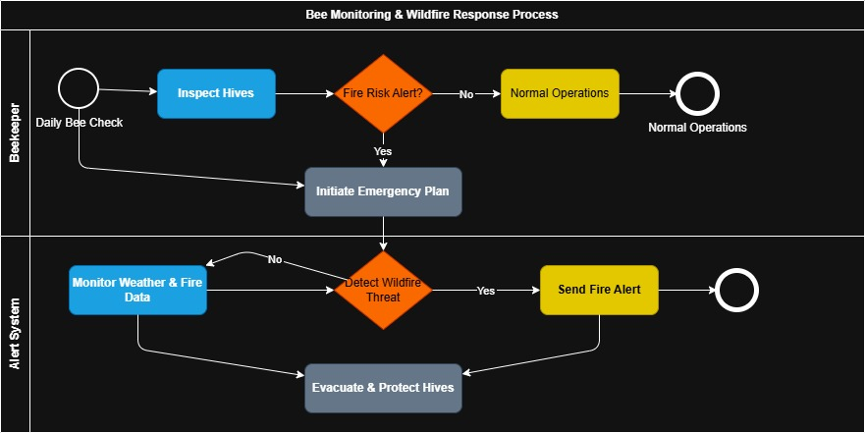

7. Conceptual Model
The conceptual model organizes the system into three distinct domains:
- Stakeholder Layer: Governance and goals (Beekeeper/Co-op).
- Control & Logic Layer: The Bee Farm Management System (BFMS), which processes sensor data against risk thresholds.
- Physical & Data Layer: The actual 45 colonies, IoT sensors (Temp/Acoustic), and the MSB external data feed.
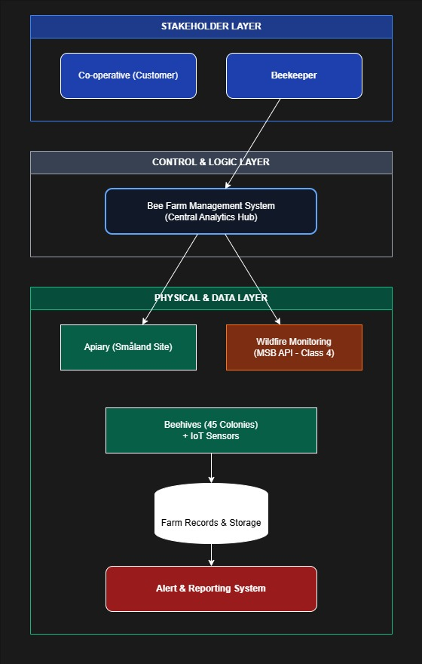

8. Information Model
The UML Information Model defines the attributes and operations for each critical entity in the high-security system:
- MSB_Wildfire_Service: Tracks brandriskklass (1-5), wind_velocity, and fire_perimeter to broadcast threats.
- Apiary_Location: Manages lat_lng coordinates and forest_proximity to verify spatial risks.
- Hive_Telemetry (IoT): Captures internal_temp_C, acoustic_hz (for bee stress), and smoke_ppm.
- Compliance_Record: Documents loss_count (capped at 5%) and action_logs to certify survival for insurance purposes.

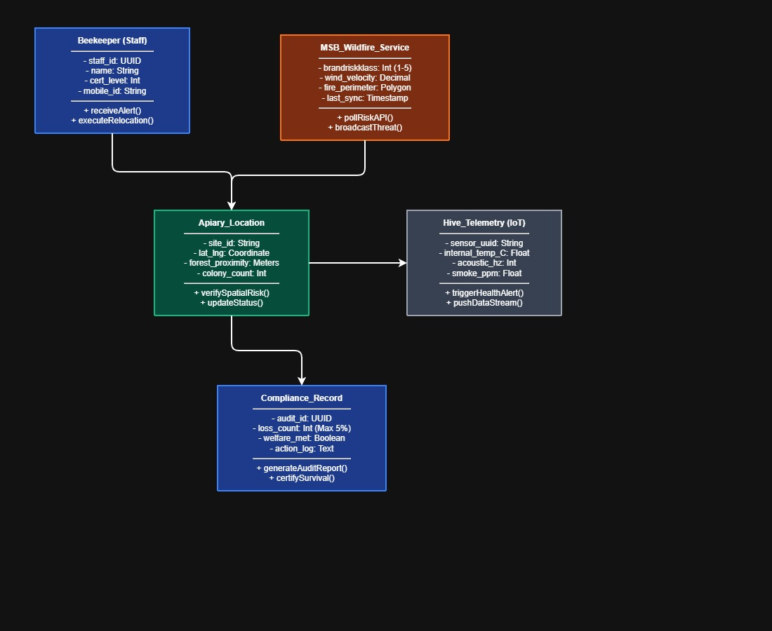

9. Entity Relationship (ER) Diagram
The ER diagram defines how these data entities relate to ensure database integrity:
- Hierarchical Ownership: A Co-operative (Customer) oversees the Beekeeper, who owns the Apiary.
- Physical Mapping: The Apiary is linked to a specific Location and contains Beehives.
- Data Generation: Beehives house Sensors that generate data for the Storage system, which ultimately drives Reporting & Alarms.

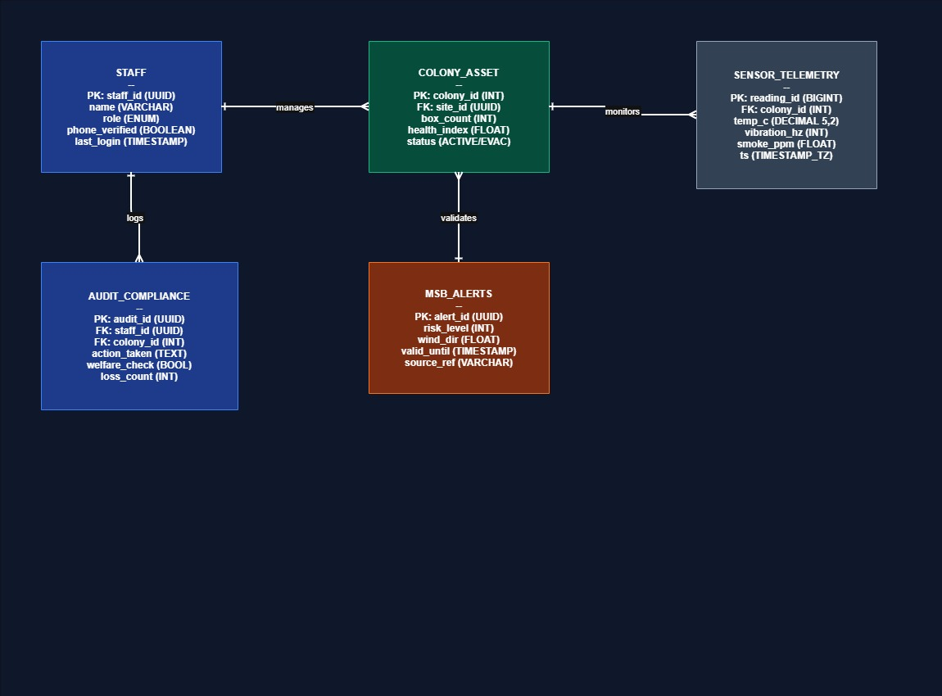

10. Security Considerations
Because the system monitors safety-critical info, the following measures are implemented:
- Access Control: Unique staff_id (UUID) and cert_level ensure only authorized personnel can execute relocations.
- Automated Syncing: Continuous polling via pollRiskAPI() ensures MSB data is always current.
- Immutable Records: The Compliance_Record uses UUIDs to prevent tampering with welfare audits.
- Redundant Alerts: Multi-channel notification via the Alert Notification System ensures the Beekeeper receives alerts regardless of location.

11. Conclusion
This project proposes an integrated wildfire monitoring and bee farm management system specifically engineered to protect biological assets in Småland during high-risk periods. By synthesizing real-time MSB Brandriskklass 4 alerts with granular IoT hive telemetry, the system empowers the beekeeper to transition from reactive honey production to proactive risk management. The layered architecture—spanning from stakeholder governance down to physical sensor mesh—ensures that every emergency action is data-driven and fully documented within a secure Farm Records Database. Ultimately, this solution not only safeguards animal welfare and limits colony losses to under 5%, but also provides the rigorous audit trail necessary to satisfy insurance requirements and maintain economic stability under increasingly volatile environmental conditions.

12. Individual Contribution Log
Name | Contribution
Student 1 | Interviews and documentation
Student 2 | Conceptual model
Student 3 | ER diagram
Student 4 | Business process diagram
Student 5 | Presentation preparation

